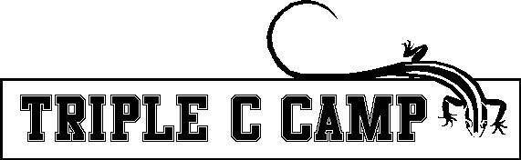

Things To Cover Every Monday With Campers
(Cover at some point during day, not necessarily all at once)

❑ Introductions, Names (Name Game)
❑ Orientation to Camp Facility
❑ Safety- shoes, rocks, woodchips, explain that rules are set to keep
them safe
- Behavioral Expectations
  - Look at the person who is speaking
  - Respond, with “yes” when spoken to
  - Our Group’s thoughts:
1-
2-
3-
❑ Counselor Expectations of campers, let them know you are here for them
❑ Goals
- Cabin group goals:
1-
2-
3-
- Individual camper goals (give campers a chance to share what they want to accomplish at camp…may want to split group
into smaller groups)
❑ Buddy Systems
❑ Bathrooms- where they are
- washing hands after animals, using the toilet, and before meals
❑ Allergies- food allergies/contact allergies
❑ Lunch Procedures
❑ Animals – fingers in cages, dogs
❑ Leave no Trace- clean up after your group
❑ Platinum Rule- Treat others the way you know they want to be treated
❑ Cabin Kapers- group effort…chart on page 2

**This Form is to be turned in on Friday with Camper Dailies

CABIN KAPER CHART WEEK ____________________
ONE COMMUNITY, ONE FAMILY
JOB | Mon | Tues | Wed | Thurs | Fri
Light Police - 2 campers  Make sure lights are off, everywhere your group leaves. | 1  2 | 1  2 | 1  2 | 1  2 | 1  2
Snack Securers – 2 campers  Collects snack bag & drink from dining hall at snack time. | 1  2 | 1  2 | 1  2 | 1  2 | 1  2
Snack Returners – 2 campers  Returns snack bag & drink to dining hall, throws away any trash in dining hall. | 1  2 | 1  2 | 1  2 | 1  2 | 1  2
Lost Property Patrol - 2 campers  Monitors items in cabin and when group moves from place to place. Prevents items from going to roundup Lost Prop. If any lost prop. in cabin at end of day, deliver it to round up. | 1  2 | 1  2 | 1  2 | 1  2 | 1  2
Dining Hall Duo- 2 campers  Wipe down table and then sweep under and around table, collect debris and deposit it into appropriate receptacle. | 1  2 | 1  2 | 1  2 | 1  2 | 1  2
Waste Watchers – 2 campers  Reminds group to prevent waste. All food waste on plates is scraped into bucket, weighed and charted. Prevents waste. | 1  2 | 1  2 | 1  2 | 1  2 | 1  2
Mailbox Monitors - 2 campers  Monitors group’s mail box at am snack, after lunch, at pm snack and prior to Round up. Collect items and delivers to counselors. | 1  2 | 1  2 | 1  2 | 1  2 | 1  2
Cabin Sweepers - 2 campers  As needed during the day, but specifically at the end of the day makes sure groups area and community bath room areas are swept. | 1  2 | 1  2 | 1  2 | 1  2 | 1  2
LEAVE ALL PLACES CLEANER THAN YOU FOUND THEM!!

